National and county life expectancy loss from particulate matter pollution in the USA

James E. Bennett^{1,2†}, Helen Tamura-Wicks^{1,2†}, Robbie M. Parks^{1,2}, Richard T. Burnett³, C. Arden Pope III⁴, Matthew J. Bechle⁵, Julian D. Marshall⁵, Goodarz Danaei⁶, Majid Ezzati^{1,2,7*}
† Equal contribution, listed alphabetically

¹ Department of Epidemiology and Biostatistics, School of Public Health, Imperial College London, London, UK.
² MRC-PHE Centre for Environment and Health, Imperial College London, London, UK.
³ Biostatistics and Epidemiology Division, Health Canada, Ottawa, Ontario, Canada.
⁴ Department of Economics, Brigham Young University, Provo, Utah, USA.
⁵ Department of Civil & Environmental Engineering, University of Washington, Seattle, Washington, USA.
⁶ Harvard T.H. Chan School of Public Health, Boston, Massachusetts, USA.
⁷ WHO Collaborating Centre on NCD Surveillance and Epidemiology, Imperial College London, London, UK.
* majid.ezzati@imperial.ac.uk

Short title: Life expectancy loss from particulate matter pollution in the USA

Abstract
Background
Exposure to fine particulate matter pollution (PM_{2.5}) is hazardous to health. The current US administration has not only resisted more stringent control of PM_{2.5}, but is also attempting to roll back current standards. Our aim was to measure the health and longevity benefits of current air pollution regulations, and of further lowering concentrations, nationally and at county level.

Methods and findings
We used vital registration and population data with information on sex, age, cause of death and county of residence. We used four Bayesian spatio-temporal models, with different adjustments for other determinants of mortality, to directly estimate mortality and life expectancy loss due to current PM_{2.5} pollution, and the benefits of reductions since 1999, nationally and by county. In 2015, PM_{2.5} pollution was responsible for between 4,099 and 67,026 deaths in women, and between 7,570 and 74,608 deaths in men, depending on the statistical model. These deaths lowered national life expectancy by 0.05 to 0.7 years for women and 0.06 to 0.7 years for men. The life expectancy loss due to PM_{2.5} was largest around Los Angeles and in Appalachia and the Deep South. At any PM_{2.5} concentration, life expectancy loss was, on average, larger in counties with lower income than in wealthier counties. Reductions in PM_{2.5} since 1999 have lowered mortality in all but 14 counties where PM_{2.5} increased slightly.

Conclusions
Recent reductions in air pollution in the USA have resulted in public health benefits. Further reductions will improve the health of the US population, and lower health inequalities.

Abbreviations: CrI, credible interval; ICD, International Classification of Disease; NCHS, National Centre for Health Statistics; PM_{2.5,} fine particulate matter.

Introduction
Clean air policies, and innovations in automotive, power generation and industrial technologies, have substantially improved air quality in the USA and other high-income countries[1]. These efforts were largely motivated by the evidence on the health hazards of air pollutants[2-6], especially fine particulate matter (PM_{2.5}). Nonetheless, in 2015, nearly 9% of the US population lived in counties with PM_{2.5} concentrations above the WHO Air Quality Guideline of 10 µg/m³ [7], and another 89% in counties with concentrations of 5-10 µg/m³ (Fig 1). Recent epidemiological cohorts have observed adverse health impacts of PM_{2.5} even at these relatively low concentrations[6, 8-11]. These findings indicate that further reducing PM_{2.5} is likely to lower mortality, especially from cardiorespiratory diseases, and increase longevity as did the late 20th century reductions[1]. Despite this evidence, there is not only resistance to more stringent control of PM_{2.5}, but also attempts to roll back current standards[12-15].
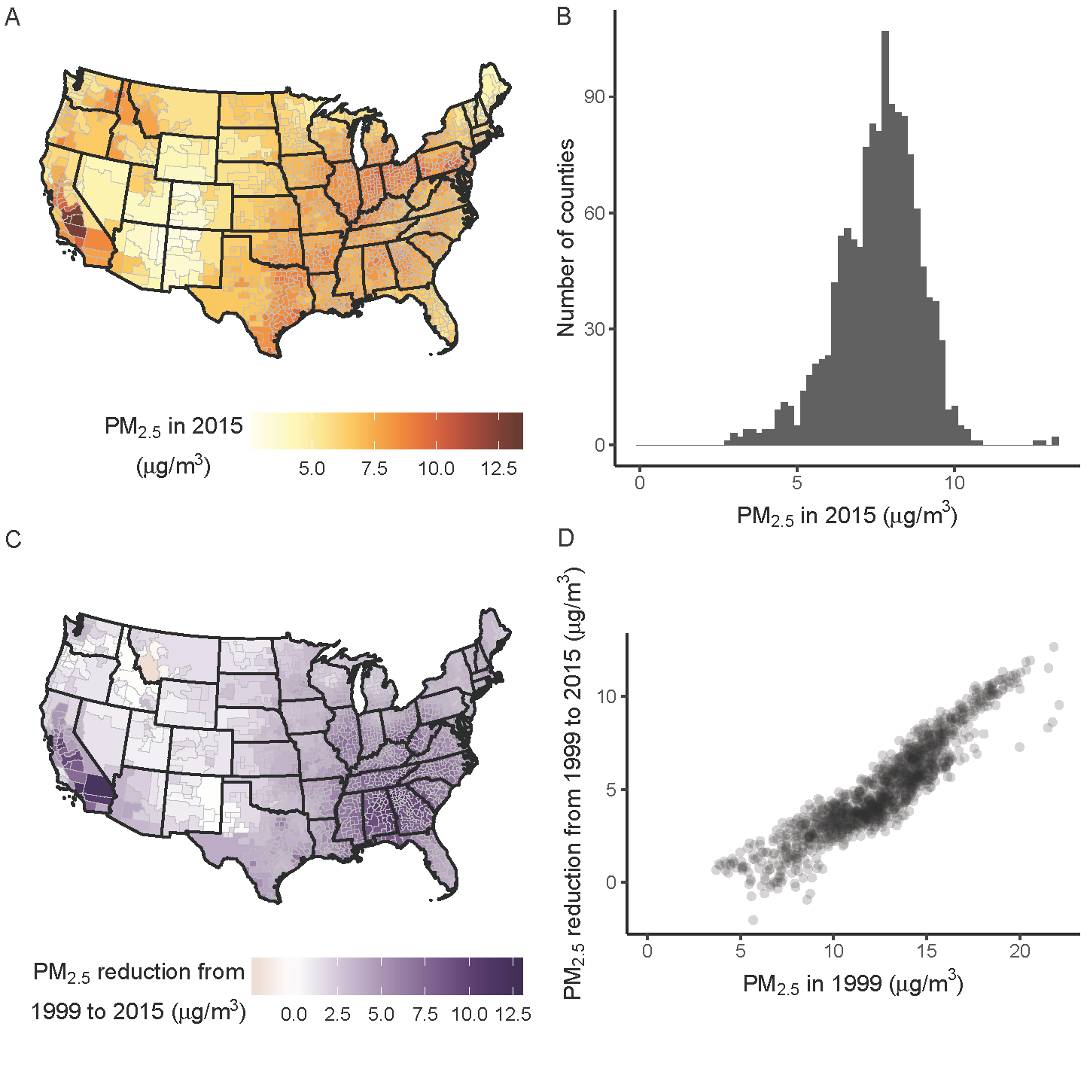

Fig 1. Population-weighted average PM_{2.5} concentration in 1339 counties or merged county units (see Supporting information for description of analysis units). (A) Concentrations in 2015. (B) Distribution of concentrations in 2015. (C) Reductions in concentrations from 1999 to 2015. (D) Relationship between concentration reductions from 1999 to 2015 and 1999 concentrations. PM_{2.5} concentrations in merged county units are population-weighted averages of constituent counties.

Evidence-based air pollution regulations and policies require quantitative estimates of the health effects of air pollution in the low-concentration range for the US population, both in terms of deaths averted as a result of past reductions and those avertable if current concentrations are further reduced[16]. Previous estimates of the mortality burden of air pollution largely involved extrapolation of risk coefficients from epidemiological cohorts, which by design were recruited in the past, to the contemporary US population (see Methods)[17-20]. The only direct analyses of longevity loss due to air pollution focused on a subset of metropolitan areas[1, 21], largely before the current low concentrations were achieved. Therefore, the fundamental question of the benefits of current regulations, and of further lowering concentrations, for preventing deaths and increasing longevity, has not been directly answered.

In this study, we used publicly available data to directly estimate the number of deaths, by age group and sex, and loss of life expectancy due to current PM_{2.5} concentrations in the entire contiguous USA (i.e., excluding Alaska and Hawaii) as well as the benefits of reductions since 1999. We present estimates of averted and avertable deaths and improved longevity nationally as well as at the small-area (county) level, which shows where the current death toll of air pollution is largest and where the health benefits of past controls have been greatest.

Methods
Study design
Our aim was to quantify, nationally as well as at the small-area (county) level, the current mortality burden of PM_{2.5} pollution and the averted mortality as a result of recent PM_{2.5} reductions. The most common source of information on the health effects of air pollution exposure is from prospective cohort studies[2-6, 9, 11]. By design, prospective cohort studies provide information on the risk associated with PM_{2.5} in a specific group of participants after a follow-up period, during which other determinants of population health also change. Therefore, estimates of excess mortality and loss of life expectancy due to air pollution in the contemporary population through application of risk estimates from prospective cohorts[6, 17], implicitly assume that the magnitude of risk associated with PM_{2.5} in the prospective cohort participants is the same as the contemporary general population.

A direct approach for measuring the mortality burden of air pollution is to analyse the association of death rates with PM_{2.5} concentration across a large number of small-area units, such as counties, appropriately adjusting for other determinants of mortality[1, 21-24]. Here, we used four Bayesian spatiotemporal models, with different degrees of adjustment for county characteristics that may also affect mortality, to directly estimate the mortality risk associated with PM_{2.5} in US counties from 1999 to 2015. We then used these associations to calculate excess deaths and life expectancy loss associated with current PM_{2.5} concentrations as well as the benefits of reductions since 1999 for all counties in the contiguous USA.

We began the analysis in 1999 for two reasons: First, reliable data on PM_{2.5} throughout the USA became available in 1999, when the US Environmental Protection Agency set up the Federal Method network of PM_{2.5} monitors[25]. Second, the USA switched from the 9th revision to the 10th revision of the International Classification of Disease (ICD) system in 1999[26]. Therefore, the post-1999 data use a consistent system of the assignment of the medical cause of death.

Data sources
We used data on deaths by sex, age, underlying cause of death and county of residence from vital registration through the National Centre for Health Statistics (NCHS) (https://www.cdc.gov/nchs/nvss/dvs_data_release.htm) and on population from the NCHS bridged-race dataset (https://www.cdc.gov/nchs/nvss/bridged_race.htm) from 1999 to 2015. From 1999 to 2015 there were a total of 41.9 million deaths in the contiguous USA; 18.4 million of these deaths were from cardiorespiratory diseases (ICD-10 codes beginning with I and J), for which there is strong evidence of an association with air pollution.

Annual average PM_{2.5} concentrations were from an integrated geographic regression model that applied a universal kriging approach to monitoring data and hundreds of geographic variables, including population, land use, emission sources, and satellite-derived estimates of particle pollution (based on optical depth) and land cover, as detailed elsewhere[27]. Annual PM_{2.5} concentrations were predicted for all years from 1999 to 2015 at all 2010 census block centroids in the contiguous USA, and were aggregated by population-weighting to county level. The PM_{2.5} concentrations can be downloaded freely through URL-to-be-added-upon-publication.

We also gathered data on other county characteristics that may affect mortality:
- Per capita income ($), adjusted for inflation using the year 2000 as a baseline, from the CA1 dataset from the Bureau of Economic Analysis (https://apps.bea.gov/regional/downloadzip.cfm) (used as log-transformed).
- Percentage of population whose family income is below the poverty threshold, from the US Census Bureau’s Small Area Income and Poverty Estimates dataset (https://www.census.gov/programs-surveys/saipe/data/datasets.All.html).
- Percentage of population who are of Black race, through the NCHS bridged-race dataset (https://www.cdc.gov/nchs/nvss/bridged_race.htm).
- Education, measured as percentage of population above the age of 25 years who have a high-school diploma or above, from the US Department of Agriculture (https://www.ers.usda.gov/data-products/county-level-data-sets/download-data/). The dataset contained US Decennial Census data for 1970, 1980, 1990 and 2000 and American Community Survey 5-year estimates for the period 2011 to 2015. We linearly interpolated between 1990 and 2000 data to estimate the percentage of population who had graduated from high-school for 1999. We similarly estimated values for each county for years from 2001 to 2010 by linearly interpolating between 2000 and 2011 data.
- Unemployment, measured as percentage of population who are unemployed, calculated by dividing the number of people who are unemployed, available from the Bureau of Labour Statistics (https://www.bls.gov/lau/), by total county population.
- Urbanicity, measured as percentage of population who live in urban areas, from the US Census Bureau’s decennial census data for 2000 and 2010 (https://factfinder.census.gov/faces/nav/jsf/pages/index.xhtml?). We linearly interpolated between 2000 and 2010 data to estimate the percentage of population living in urban areas for 2001 to 2009. We used data from the year 2000 for 1999, and those from 2010 for 2011 to 2015.
- Cumulative smoking, proxied by log-transformed age-standardised lung cancer death rates as in previous population-based analyses[1, 28-30]. We calculated lung cancer death rates using the above-mentioned deaths on lung cancer (ICD 10 codes C33 and C34) and population.

Units of analysis
In 2015, there were 3,108 counties in the contiguous USA. Over time, some counties were merged or split to create new counties. To avoid inconsistent analysis units over time, such counties were combined for the entire analysis period in order to have an unambiguously consistent set of analysis units. This resulted in 3,082 non-overlapping county units in the contiguous USA with consistent boundaries for the entire analysis period.

The populations of these 3,082 counties from 1999 to 2015 ranged from 55 to 10,112,255. In small counties, some age groups had zero population in some years, which makes it impossible to calculate death rates. To avoid zero populations, we recursively merged counties with sex-specific populations smaller than 25,000 in any year with their neighbours, until the populations in all sex-year combinations surpassed 25,000 in the newly formed county units. We merged counties without crossing state boundaries or combining urban and rural counties. We determined the urbanicity of each county from the NCHS’s Urban-Rural Classification Scheme for Counties in 2006 (https://www.cdc.gov/nchs/data_access/urban_rural.htm), which divides counties into six categories – large central metro, large fringe metro, medium metro, small metro, micropolitan and non-core, – based on their population and overlap with metropolitan or micropolitan statistical areas. We considered counties categorised under the first four as urban counties, and the last two as rural counties. Using this algorithm, we created a total of 1,339 county units in the contiguous USA which were used for statistical analyses described below. PM_{2.5} concentrations for each constituent counties were population-weighted up to the level of the newly formed county units. The median absolute difference in PM_{2.5} concentration between the merged counties and their constituents from 1999 to 2015 was 0.28 μg/m³.

Statistical methods
We used four Bayesian spatiotemporal models, with different degrees of adjustment for county characteristics that may also affect mortality, to directly estimate the proportional (percent) increase in county-level age-specific death rates from cardiorespiratory diseases associated with the county’s annual PM_{2.5} concentration.

The four models, described in detail in the Supporting information, had different degrees of adjustment for time-varying county-level characteristics that may also influence mortality. The unadjusted model had no adjustments for county-level characteristics and simply quantifies the observed association of county-level death rates with their PM_{2.5} concentrations. The covariate model adjusted for per capita income; percentage of population whose family income is below the poverty threshold, who are of Black race, who have graduated from high-school, who live in urban areas, and who are unemployed; and a proxy for cumulative smoking. This model is analogous to the approach used by cohort studies, which typically adjust for baseline characteristics of participants. The covariate-and-county model largely removed systematic variations in death rates and PM_{2.5} concentration across counties, through the use of county-specific random intercepts, hence implicitly adjusted for unobserved characteristics that systematically lead to higher or lower pollution and mortality in each county. In this model, the mortality effects of air pollution are mainly inferred through differential changes over time in death rates and PM_{2.5} concentrations across counties. The restrictive model included both county-specific random intercepts and random slopes, hence also implicitly adjusted for (linear) differential change in death rates and PM_{2.5} concentrations across countries. By design, this model leaves little spatial or temporal variation in death rates to be associated with PM_{2.5}. (Computer code for the models will be available through http://www.globalenvhealth.org/ upon publication). We report national results using all four models and county results using the covariate-and-county model.

These four models were applied to county-level cardiorespiratory death rates, separately by sex and five-year age groups to obtain the proportional increase in death rates for each 1 µg/m³ of PM_{2.5}. We used the rate ratios from these models (S1 Fig) to calculate how many cardiorespiratory deaths in each five-year age group would be averted if PM_{2.5} concentration in each county were the same as the lowest observed concentration (2.8 µg/m³, in Apache, Arizona). This value is similar to the 2.5-3.5 µg/m³ concentration used by the US EPA as a policy-relevant background level[31].

National estimates were obtained by summing the number of averted deaths in each age group across counties. We used a lifetable to convert the estimated reduction in death rates that would be expected from reaching this lower concentration to gain in life expectancy[28, 32], at the county as well as national level. We conducted a similar analysis to calculate the number of averted deaths and life expectancy gain as a result of PM_{2.5} reductions achieved from 1999 to 2015.

Results
PM_{2.5} pollution in excess of the lowest observed concentration of 2.8 µg/m³ was responsible for between 4,099 and 67,026 deaths from cardiorespiratory diseases (0.7-12.1% of all cardiorespiratory deaths) in women and between 7,570 and 74,608 deaths (1.4-13.6% of all cardiorespiratory deaths) in men in the contiguous USA in 2015, in the four alternative models. These deaths in turn lowered national life expectancy by 0.05-0.7 years for women and 0.06-0.7 years for men (Fig 2A). National life expectancy loss was 0.57 (95% credible interval, CrI, 0.56-0.58) and 0.52 (0.51-0.53) years for women and men, respectively, in the covariate model, and 0.14 (0.12-0.16) and 0.13 (0.11-0.15) years in the covariate-and-county model, which adjusts not only for observed county characteristics, but also, additionally and implicitly, for the unobserved characteristics that lead to systematic variations in mortality. County level life expectancy loss in the covariate-and-county model ranged from <0.05 years in lower-pollution mid-western and Rocky Mountain counties to >0.3 years in and around Los Angeles and in high-pollution and high-mortality counties in Appalachia and the Deep South (Fig 2B). Counties experiencing a loss of 0.2 years or more in female life expectancy accounted for 14.2% of the female population, and those experiencing a loss of 0.2 years in male life expectancy accounted for 4.4% of male population.
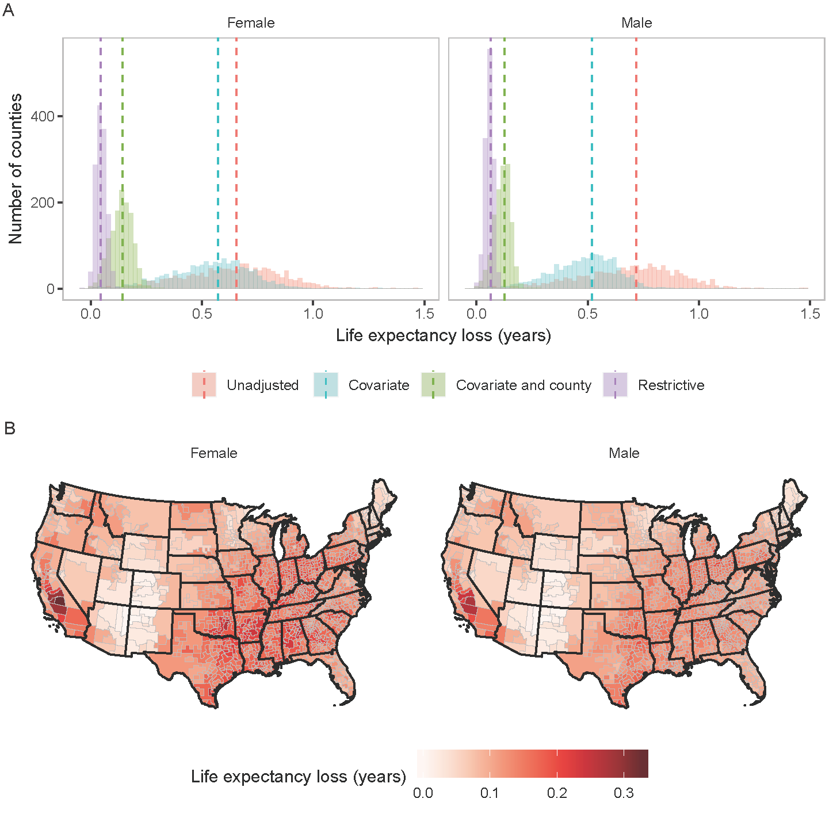

Fig 2. Life expectancy loss in 2015 from PM_{2.5} exceeding the observed minimum of 2.8 µg/m³. (A) Distribution of county-level life expectancy losses estimated from the four models (histograms) and the life expectancy losses at the national level estimated from the four models (dotted lines). (B) Life expectancy losses by county, estimated from the covariate-and-county model.

Importantly, life expectancy loss due to PM_{2.5} was larger in counties with lower income than in wealthier counties (Fig 3). For example, in counties with PM_{2.5} concentrations exceeding the observed minimum by 4 to 6 µg/m³, median life expectancy loss for females in the covariate-and-county model was 0.16 years (95% CrI 0.14 to 0.18) in the poorest quintile and 0.12 years (95% CrI 0.10-0.14) in the wealthiest quintile; for males, it was 0.13 years (0.11-0.15) in the poorest quintile and 0.11 years (0.10-0.13) in the wealthiest quintile. This inequality in mortality burden occurs largely because lower-income counties tend to have higher baseline death rates and hence experience a larger absolute number of deaths as a result of air pollution.
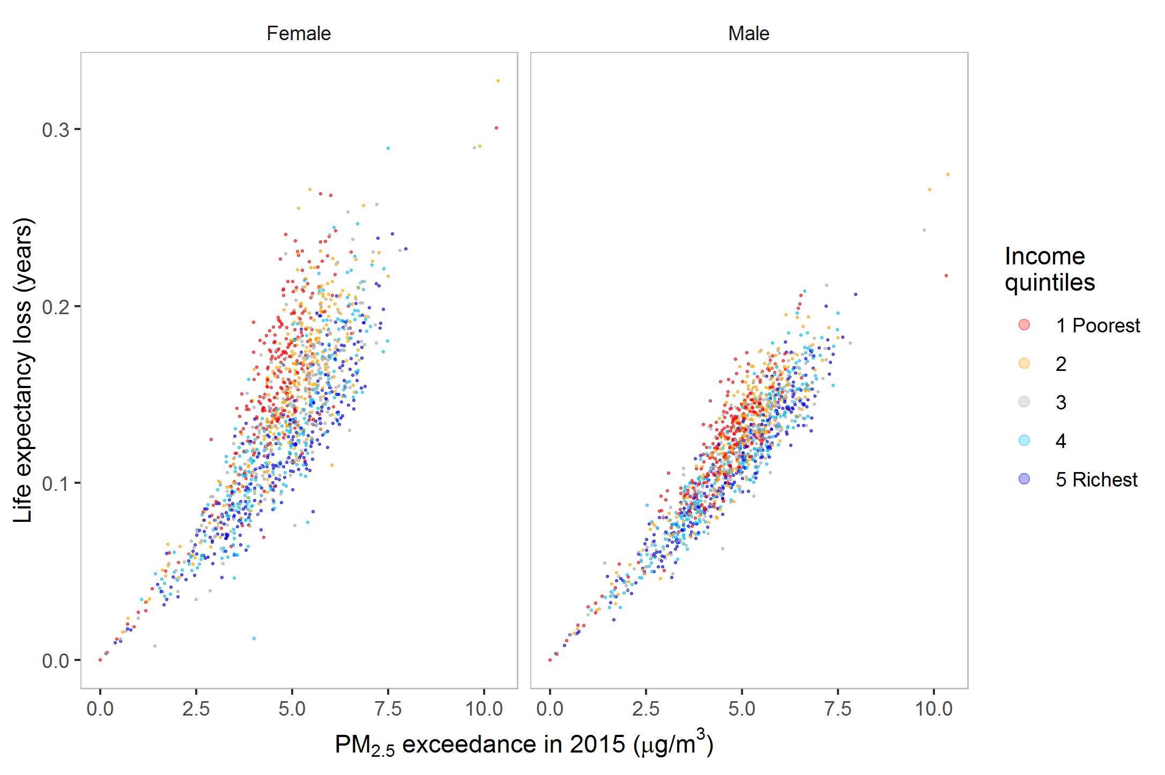
Fig 3. County level life expectancy losses in 2015 from PM_{2.5} exceeding observed minimum of 2.8 µg/m³, estimated from the covariate-and-county model, divided by quintiles of per capita income. The income ranges in the five quintiles are 17,400-24,900, 24,900-27,400, 27,400-30,100, 30,100-34,200 and 34,200-114,000 dollars (adjusted for inflation with 2000 as the base year).

Nationally, population-weighted average PM_{2.5} concentration in the contiguous USA declined from 13.6 µg/m³ in 1999 to 8.0 µg/m³ in 2015. Pollution reduction was largest in the most polluted areas, such as southern California and the Deep South, where PM_{2.5} declined by >10 µg/m³ from 1999 to 2015 (Fig 1). While current PM_{2.5} pollution is responsible for a significant mortality burden and loss of longevity, reductions in pollution since the late 1990s have benefited virtually the entire country, with the exception of 14 counties where PM_{2.5} increased slightly over this period (median increase of 0.2 µg/m³) (Fig 4). The national life expectancy gain as a result of these reductions was 0.69 years (95% CrI 0.68-0.71) for women and 0.60 years (0.59-0.61) for men in the covariate model; and 0.17 years (0.15-0.19) for women and 0.14 years (0.12-0.16) for men in the covariate-and-county model. For comparison, the overall observed increase in US life expectancy from 1999 to 2015 was 2.5 and 2.0 years for women and men, respectively. The life expectancy gain estimated using the covariate-and-county model surpassed 0.2 years in 376 counties (31.2% of population) for women and 196 counties (17.4% of population) for men. 111 counties (11.6% of population) for women and 19 counties (6.1% of population) for men, mostly in California and the Deep South, gained more than 0.3 years of life expectancy.
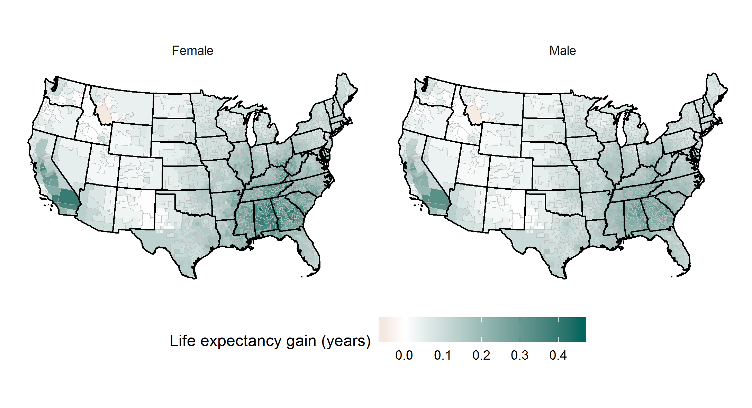
Fig 4. Contribution of PM_{2.5} reduction to life expectancy gains from 1999 to 2015, estimated using the covariate-and-county model.

Discussion
In this direct national analysis of mortality and life expectancy loss due to fine particulate matter pollution, we find that current air pollution concentrations, which are relatively low by historical standards, are associated with a significant health burden after any reasonable control for other local determinants of mortality. The loss of longevity is larger in poorer counties contributing to nation-wide health inequalities. We also find that reductions in air pollution since 1999 have contributed to the longevity gains in the US population, with larger benefits especially in California and the Deep South where PM_{2.5} declined more than the national average.

Two previous direct analyses of longevity loss due to air pollution in the USA focused on a subset of metro areas[1, 21], largely before the current low concentrations were achieved, and hence are not directly comparable to our results. One study, using data from ~1980 to ~2000 from 211 counties in 51 metropolitan areas[1], found a life expectancy effect that was between the estimated effects of our covariate-and-county and covariate models; the other, using data from 2000 to 2007 in 545 counties, found a life expectancy effect similar to our covariate-and-county model[21]. Neither study reported national or county-level life expectancy loss due to current pollution levels. Indirect estimate of life expectancy loss due to PM_{2.5} in the USA, with use of pooled hazard ratios from prospective cohort studies, is 0.38 years[20], which is midway between the estimates from our covariate-and-county and covariate models.

The main strength of our study is making direct estimates of the effects of PM_{2.5} pollution on death rates of the contemporary US population, nationally and for all counties or clusters of small counties. We further stratified our results by county income quintiles which reveals the role of air pollution on life expectancy inequalities. We present results using a range of model specifications, which shows how different adjustments for time-varying county-level determinants of mortality influence the estimated effect of air pollution. Finally, and importantly, the data used in our analysis are publicly available, as is the computer code for our statistical models, making our analysis fully transparent and replicable by others. Our analysis also meets the recent requirement of being based on publicly available datasets[15, 33]. The main limitation of our study, similar to other observational studies, is that it is not guaranteed for the observed associations to be causal. We did not have annual county-level data on other important determinants of mortality, such as healthcare access and quality and diet. These factors are however, implicitly, adjusted for in our covariate-and-county model. Although lung cancer is a robust proxy for the cumulative hazards of smoking in a population[29, 30], it is also affected by air pollution, albeit to a much smaller degree than smoking, and hence its use to control for smoking leads to somewhat conservative estimates of the effect of air pollution. Finally, the modelled PM_{2.5} concentrations may have some error which typically lower the estimated effect of air pollution towards the null.

In summary, public health policy and regulatory efforts in the USA have spurred technological innovations and contributed to reduced air pollution. Although the health benefits of large pollution reductions in major metropolitan areas in the twentieth century[1] are widely acknowledged, there is policy resistance to actions that would further lower the concentration of pollutants such as PM_{2.5}, most recently through requirements that constrain the evaluation of health effects of air pollution to publicly available datasets[15, 33]. Our direct national analysis of the mortality burden of PM_{2.5} pollution, using publicly available data and with a range of analytical models, demonstrates that current PM_{2.5} continues to contribute to mortality and loss of longevity in the USA, with larger harms in poorer counties. Our results provide evidence that further lowering PM_{2.5} pollution will continue to benefit the health of the entire US population, and will lower health inequalities.

Acknowledgements
We thank Vasilis Kontis and Christopher Paciorek for valuable input on statistical modelling and its implementation. This research was supported by the US EPA as part of the Center for Clean Air Climate Solution (CACES) (assistance agreement number R835873) and by the Wellcome Trust (grants 205208/Z/16/Z and 209376/Z/17/Z and Institutional Strategic Support Fund). The paper has not been formally reviewed by EPA. The views expressed in this document are solely those of authors and do not necessarily reflect those of the Agency. EPA does not endorse any products or commercial services mentioned in this publication.

References
1. Pope CA, Ezzati M, Dockery DW. Fine-particulate air pollution and life expectancy in the United States. New England Journal of Medicine. 2009;360(4):376-86.
2. Dockery DW, Pope CA, 3rd, Xu X, Spengler JD, Ware JH, Fay ME, et al. An association between air pollution and mortality in six U.S. cities. The New England journal of medicine. 1993;329(24):1753-9.
3. Pope CA, 3rd, Burnett RT, Thun MJ, Calle EE, Krewski D, Ito K, et al. Lung cancer, cardiopulmonary mortality, and long-term exposure to fine particulate air pollution. JAMA. 2002;287(9):1132-41.
4. Pope CA, 3rd, Dockery DW. Health effects of fine particulate air pollution: lines that connect. Journal of the Air & Waste Management Association (1995). 2006;56(6):709-42.
5. Brook R, Rajagopalan S, III CP, Brook J, Bhatnagar A, Diez-Rouz A, et al. Particulate matter air pollution and cardiovascular disease: an update to the scientific statement from the American Heart Association. Circulation. 2010;121:2331-78.
6. Burnett R, Chen H, Szyszkowicz M, Fann N, Hubbell B, Pope CA, et al. Global estimates of mortality associated with long-term exposure to outdoor fine particulate matter. Proceedings of the National Academy of Sciences of the United States of America. 2018;115(38):9592-7.
7. World Health Organization. WHO air quality guidelines for particulate matter, ozone, nitrogen dioxide and sulfur dioxide - Global update 2005 - Summary of risk assessment, 2006. 2006.
8. Vodonos A, Abu Awad Y, Schwartz J. The concentration-response between long-term PM2.5 exposure and mortality; a meta-regression approach. Environmental Research. 2018;166:677-89.
9. Di Q, Dominici F, Schwartz JD. Air pollution and mortality in the Medicare population. The New England journal of medicine. 2017;377(15):1498-9.
10. Pinault LL, Weichenthal S, Crouse DL, Brauer M, Erickson A, Donkelaar AV, et al. Associations between fine particulate matter and mortality in the 2001 Canadian Census Health and Environment Cohort. Environ Res. 2017;159:406-15.
11. Beelen R, Raaschou-Nielsen O, Stafoggia M, Andersen ZJ, Weinmayr G, Hoffmann B, et al. Effects of long-term exposure to air pollution on natural-cause mortality: an analysis of 22 European cohorts within the multicentre ESCAPE project. 2014;383(9919):785-95.
12. Reilly S. Trump’s EPA scraps air pollution science review panels: Science; 2018 [Available from: https://www.sciencemag.org/news/2018/10/trump-s-epa-scraps-air-pollution-science-review-panels.
13. Heikkinen N. To kill climate rule, Trump’s EPA wants to redefine danger of soot: Science; 2018 [Available from: https://www.sciencemag.org/news/2018/08/kill-climate-rule-trump-s-epa-wants-redefine-danger-soot.
14. Hirji Z, Brown H. Trump tweeted out a map of air pollution. Here’s what’s wrong with it.: BuzzFeed News; 2018 [Available from: https://www.buzzfeednews.com/article/zahrahirji/trump-air-pollution-tweet.
15. Wagner W, Fisher E, Pascual P. Whose science? A new era in regulatory “science wars”. Science. 2018;362(6415):636.
16. Health Effects Institute. Assessing health impact of air quality regulations: concepts and methods for accountability research. 2003.
17. Fann N, Kim SY, Olives C, Sheppard L. Estimated changes in life expectancy and adult mortality resulting from declining PM2.5 exposures in the contiguous United States: 1980-2010. Environ Health Perspect. 2017;125(9):097003.
18. U.S. Environmental Protection Agency. The benefits and costs of the Clean Air Act, 1970 to 1990. 1997.
19. U.S. Environmental Protection Agency. The benefits and costs of the Clean Air Act from 1990 to 2020. 2011.
20. Apte JS, Brauer M, Cohen AJ, Ezzati M, Pope CA. Ambient PM2.5 reduces global and regional life expectancy. Environ Sci Tech Let. 2018;5(9):546-51.
21. Correia AW, Pope CA, 3rd, Dockery DW, Wang Y, Ezzati M, Dominici F. Effect of air pollution control on life expectancy in the United States: an analysis of 545 U.S. counties for the period from 2000 to 2007. Epidemiology. 2013;24(1):23-31.
22. Elliott P, Wakefield JC, Best NG. Spatial Epidemiology: methods and applications: Oxford University Press; 2001.
23. Lave LB, Seskin EP. Air pollution and human health. Science. 1970;169(3947):723.
24. Özkaynak H, Thurston GD. Associations between 1980 US mortality rates and alternative measures of airborne particle concentration. 1987;7(4):449-61.
25. Kim S-Y, Olives C, Sheppard L, Sampson PD, Larson TV, Keller JP, et al. Historical prediction modeling approach for estimating long-term concentrations of PM2.5 in cohort studies before the 1999 implementation of widespread monitoring. Environmental health perspectives. 2017;125(1):38-46.
26. Centers for Disease Control and Prevention. International Classification of Diseases 10th Revision (ICD-10) [Available from: https://www.cdc.gov/nchs/data/dvs/icd10fct.pdf.
27. Kim SY, Bechle M, Hankey S, Sheppard L, Szpiro AA, Marshall JD. Concentrations of criteria pollutants in the contiguous U.S., 1979 – 2015: Role of model parsimony in integrated empirical geographic regression: University of Washington Biostatistics Working Paper Series; 2018 [Available from: https://biostats.bepress.com/uwbiostat/.
28. Danaei G, Rimm EB, Oza S, Kulkarni SC, Murray CJ, Ezzati M. The promise of prevention: the effects of four preventable risk factors on national life expectancy and life expectancy disparities by race and county in the United States. PLoS Med. 2010;7(3):e1000248.
29. Oza S, Thun MJ, Henley SJ, Lopez AD, Ezzati M. How many deaths are attributable to smoking in the United States? Comparison of methods for estimating smoking-attributable mortality when smoking prevalence changes. Prev Med. 2011;52(6):428-33.
30. Peto R, Lopez AD, Boreham J, Thun M, Heath C, Jr. Mortality from tobacco in developed countries: indirect estimation from national vital statistics. Lancet. 1992;339(8804):1268-78.
31. Post E, Watts K, Al-Hussainy E, Neubig E. Particulate matter health risk assessment for selected urban areas. Available at https://www3.epa.gov/ttn/naaqs/standards/pm/data/pm_risk_tsd_finalreport_2005_mainbody.pdf. Prepared for Office of Air Quality Planning and Standards, U.S. Environmental Protection Agency, Research Triangle Park, NC; 2005.
32. Preston S, Heuveline P, Guillot M. Demography: measuring and modeling population processes2000.
33. Cornwall W. New rule could force EPA to ignore major human health studies Science; 2018 [Available from: http://www.sciencemag.org/news/2018/04/new-rule-could-force-epa-ignore-major-human-health-studies.

Supporting information
S1 Text. Detailed specifications of statistical models.
S1 Table. Models used for relating county death rates to PM2.5 concentrations.
S1 Fig. Sex and age group specific rate ratios per 10 µg/m³ of PM2.5 for cardiorespiratory deaths. The rate rations were estimated from four different Bayesian spatio-temporal models described in Statistical Methods.

